

|  |  |  |  |  |  |  |  |  |
| --- | --- | --- | --- | --- | --- | --- | --- | --- |
|  | | | | | | | | |
|  | | La 3 | Indicators of Compromise | | | | |  | |
|  |  | | | | | | |  |
|  | | | |  |  | | | |
|  | | | | Cesar Munguia |  | | | |
|  | | | | 11/06/2023—IS-3523-004—Ian Burres |  | | | |
|  | | |  | | |  | | |



|  |  |  |  |  |  |  |  |  |
| --- | --- | --- | --- | --- | --- | --- | --- | --- |
|  |  | | |  |  | | |  |
|  | INSTRUCTIONS | | | | | | |  |
|  |  | | |  |  | | |  |
|  |  | |  | | |  | |  |
|  |  |  | 1. In this lab, you will choose 2 vulnerabilities present in Metasploitable 2 and then identify a TTP contained in the MITRE ATTACK framework that could be used to exploit each vulnerability. Once you have chosen said vulnerabilities, you will exploit them using Metasploit and/or any other tool you are familiar with.  2. Using Splunk, Wireshark, the Sysinternals Suite of tools, Netminer, and Suricata, you will identify the Indicators of Compromise that corroborate the attacks you executed. In other words, what evidence is available to prove the attacker executed attack A and attack B | | |  |  |  |
|  | | | | |
|  |  |  |  |
|  |  |



In this lab, I will start by stating the vulnerability, then mapping such vulnerability to the MITRE ATT&CK framework, then state one particular APT group that has used that same technique with malicious intent, then try to exploit the vulnerability myself using the machines available to me against Metasploitable 2, and finally play the defender side and try to prevent such attack using my own Suricata rules, while at the same time use a set of tools to determine the indicators of compromise.

In order for me to understand the type of vulnerabilities available in Metasploitable 2 I had to go look at the official documentation page of the team responsible of creating this machine, Rapid7. While at the documentation website, under Installing Metasploit > Setting Up a Vulnerable Target > Metasploitable 2 Exploitability GuideI started reading the document and learned about the different types of vulnerabilities. Some examples are: backdoors in port 21 and port 6667, unintentional backdoors, weak passwords (susceptible to brute-force attacks), and vulnerable web services like Mutillidae and DVWA. Both of these web services are susceptible to SQL injection, cross-site scripting, click-jacking, DOM injection, JavaScript injection, JSON injection, and many more (Metasploit Documentation, n.d.). Out of all of these vulnerabilities, the one that stood out the most to me and the one I was more curious about was cross-site scripting (XSS). So, the first vulnerability I will choose is going to be more web-related which deals with taking input from a user.

Mapping this vulnerability to the MITRE ATT&CK framework was somewhat hard for me because, at first, I did not know exactly what stage to look at primarily (reconnaissance, initial access, execution, etc.). However, with the professor’s assistance I was able to find out the name and the exact technique number for this particular vulnerability. Based on the framework, the actual name is Drive-by Compromise which is essentially the same thing as cross-site scripting but with a different name. I was able to recognize it as I read the information and compared with my own definition of XSS based on other sources and they both were similar. Some general information is as follows: technique ID is T1189; no sub-techniques; the tactic is Initial Access; the platforms are Linux, SaaS (Software as a service), Windows, and macOS. According to the MITRE website, “[a]dversaries may gain access to a system through a user visiting a website over the normal course of browsing. With this technique, the user’s web browser is typically targeted for exploitation…”. It also states that “[a] legitimate website is compromised where adversaries have injected some form of malicious code…” and “… the insertion of any other kind of object that can be used to display web content or contain a script that executes on the visiting client” (MITRE ATT&CK, n.d.). To summarize all this information in brief words, cross-site scripting (or better known as Drive-by Compromise) is a technique used where the hacker finds a vulnerable website that he can exploit and then use a method to insert some sort of script to execute whenever the victim enters the website. This can be done with the goal of stealing login credentials and/or application access tokens so at the same time they can use them to have access to the internal network.

There were at least more than 35 groups that had utilized this technique in real-world scenarios. However, for the sake of time I only looked at one particular group which was the Elderwood group. The group ID is G0066, and according to the MITRE website the brief description asserts that the “[e]lderwood has delivered zero-days exploits and malware to victims by injecting malicious code into specific public web pages visited by targets withing a particular sector”. Basically, the Elderwood was an espionage group that resided in China which was responsible of the Google intrusion, or better known as Operation Aurora. This group used many techniques, but I got really curious about how exactly they were able to execute this particular attack and with what intentions. For that reason, I opened the links available in order for me to learn and explore more about them. After reading the articles *“Elderwood Project, Who is Behind Op. Aurora and Ongoing Attacks?”* and *“Stealing US Business Secrets: Experts ID two Huge Cyber ‘Gangs’ in China”* I was able to grasp important aspects about this group. As I’ve stated before, this group used more techniques than just cross-site scripting in order for them to gain access to a system. This group was successful at committing these cybercrimes because they were able to create and utilize zero-days exploits. Zero-days exploits are hard for companies to countermeasure with because they’re vulnerabilities that they never thought of or that they aren’t aware of. This group utilized one after another, when the attackers realized that one of their zero-days was patched/fixed they would execute another one right afterwards to maintain control. The fact that they had several zero-days made them extremely powerful and dangerous. Both articles emphasized the idea of a watering hole attack that Elderwood utilized. At first, I was a bit confused about this idea but the following image helped me understand it (refer to screenshot 1). Attackers would find a website that a particular target group would visit regularly and exploit it by injecting malicious scripts and wait patiently for them to visit the website. Their main goal was to steal intelligence and intellectual property for future sell in the dark web.

Now, I will try my best to exploit this vulnerability myself by imitating the same actions of the previously stated group. I remember that the Metasploit documentation stated that the DVWA web service was susceptible to cross-site scripting and so I used this web service as my domain. First of all, I want to emphasize that I used the Flare VM as the victim, meaning this will be the computer that is going to access the altered website. Let’s also assume that Kali Linux VM was responsible of injecting the malicious script to the website. Using the Flare VM I opened the web browser and typed 172.16.2.3 to access Metasploitable’s web services, then clicked on the DVWA link (refer to screenshot 2). Then, I inputted admin for Username and password for Password. While at the index.php page I clicked on DVWA Security and set the security level to low and clicked Submit (refer to screenshot 3). I set the level to low because I wanted to attempt this attack as simple as possible and without any issues to show the exploit in action. Then, let’s also assume that the victim had previously opened a phishing email and clicked on the link attached to it redirecting him to this web page (refer to screenshot 4). Let’s also assume that the hacker used the phishing email targeted at this specific individual and also knew the victim’s username. The link contained a malicious script within the URL, which caused it to open the altered web page with a different look. The malicious script I’m talking about is a script I was able to find a in an article that showed me how to execute the attack step-by-step. According to the article called “*5 Real-World Cross Site Scripting Examples*”, the script would prompt the user to enter their credentials which the hacker is able to see (refer to screenshot 5 for an insight of the malicious script). Once the victim hits Logon, then the attack has been successfully executed and the “hacker” is able to steal the credentials in order to access the internal network, just as the Elderwood did with the watering hole attacks. My next step is to play the defender side and try to detect the indicators of compromise and to create Suricata rules to prevent this attack from happening again.

I self-taught this tool in Kali called Burp Suite that lets me use a web proxy which serves as an intermediary between a client and a server and allows me to intercept and inspect traffic. While at the application, I went to the same process of accessing the website and inputting my credentials as if I was the victim and these were my findings: I was able to intercept the link that the victim had clicked with the GET request packet and the password inputted (refer to screenshot 6 & 7). The reason I was able to see almost all content in plain text is because HTTP protocol is unencrypted. I also utilized Wireshark to intercept the packets sent in the network and found the same results. I looked for the GET packet and followed the TCP stream to see the entire communication (refer to screenshot 8). I opened the GET packet to inspect and found out that I had the same results as in the Burp application, the victim’s stolen password is “password+test”. I utilized another tool called Network Miner that helped me get some helpful information (refer to screenshot 9). Based on the information gathered with this application, these were my findings: 172.16.2.17 (Flare VM) was the victim’s IP address, it had a Windows operating system, the communication was composed of 46 packets sent and 43 packets received, the session was established with server 172.16.2.3 (Meta) with port 80 (HTTP). Now, I will try to prevent and detect this attack from happening using Suricata and viewing the alerts in Splunk.

As I began to think how I should go about preventing and detecting this attack from happening the first thing that came to my mind was to create rules in Suricata with protocols HTTP or TCP since this were the main protocols used for the client-server connection and communication. At first, I struggled to create a specific rule that would prevent a XSS attack because I couldn’t just drop all HTTP packets coming to Meta because that would simply be inefficient and it would have a greater negative effect on the network itself. For that reason, I relied on the Suricata documentation to help me create a specific rule for this situation. As I read the documentation, I found that I could use the “http_uri” modifier keyword in the rule’s options section (Suricata documentation, n.d.). This keyword along with the “content” option would allow me to write a rule specific for the attack. In the IPS VM, inside the local.rules file I wrote the following rules (refer to screenshot 10). The first rule works like this: if the victim’s URL contained “/dvwa/vulnerabilities/xss_r/name=” in it, then it would alert the SIEM since this is the URL where the presumable malicious script is. Let’s assume that the attacks were detected months after it occurred and this rule was only to alert while they fixed the website. When the victim hits Logon, it redirects him to the URL containing “/?password=”, for that reason the second rule could be so that if another user typed their credentials and hit Logon, then it would alert them and let them know that another password could be potentially compromised. I could’ve just dropped all those packets to prevent the attacks from happening but I just decided to show that I was able to detect such attacks using alerts. Finally, I looked at the fast.log file in the IPS VM and as well as on Splunk GUI to see the logs and alerts (refer to screenshot 11 & 12).

The second vulnerability I chose to investigate further are weak passwords, which could lead to brute-force attacks. According to the MITRE framework, some general information are as follows: technique ID is T1110; sub-techniques are T1110.001, T1110.002, T1110.003, and T1110.004; the tactic is Credential Access; the platforms are Azure AD, Containers, Google Workspace, IaaS, Linux, Network, Office 365, SaaS, Windows, and macOS. The website states that “[a]dversaries may use brute force techniques to gain access to accounts when passwords are unknown or when password hashes are obtained”. One important aspect that the framework explains in the web page is that the attacker could utilize this method while being either in a service that constantly checks for the validity of the password (online) or offline using password hashes (MITRE ATT&CK, n.d.). Most of the time when attacker execute this attack, they do it with the help of a special program that can iterate itself many times. The MITRE web page also states that “[b]rute forcing credentials may take place at various points during a breach.”, meaning that it may not occurred, for example, only in the initial phase.

The advanced persistent threat (APT) I chose is HEXANE or also known as Lyceum. Some general information about this APT are as follows: ID is G1001; some associated groups are Lyceum, Siamesekitten, and Spirlin; some contributors are Dragos Threat Intelligence, Mindaugas Gudzis, and BT Security. This is an espionage group that has been in the cyber industry since at least 2017. It has targeted different industries’ systems with those including oil, gas, telecommunications, aviation, and ISPs. Some country victims are Israel, Saudi Arabia, Kuwait, Morocco, and Tunisia. After reading the reference article called “Lyceum Takes Center Stage in Middle East Campaign” I learned that the APT group used different vectors with some including a RAT called DanBot that allowed basic HTTP and DNS-based communication and remote command execution, a PowerShell script, and a program called “Decrypt-RDCMan.ps1”. According to the article, this toolkit allowed them to “… decrypt passwords stored in the RDCMan configuration file, which store[d] details of servers and encrypted credentials to quickly establish remote desktop sessions”. They used this tool approximately one hour after having initial access to the system. In the next step, I will try to imitate the same process that this group used but in my case against Metasploitable 2.

After learning that Lyceum used a tool/program to help them execute their attack I wanted to do the same thing but, in my case, not as a complex as their program was. For that reason, I started doing my research about how I could the same thing using a much simpler and friendlier program. I started looking at Youtube videos and encountered myself with a video that showed me step-by-step how to execute a successful brute force attack using the same application I used in my first attack, Burp Suite. The video is called “How Easy Is It For Hackers To Brute Force Login Pages?!” posted in YouTube by Loi Lian Yang, a Certified Information Systems Security Professional (CISSP), Certified Ethical Hacker, and CompTIA Security+ cybersecurity consultant. The video shows how to brute force a random login page in a sandbox; however, I will also use the DVWA web service log in page that I used in the previous attack.

Using Kali, I started the process by starting up the Burp application using the command prompt and for that I used command **burpsuite &**. Then, I followed almost the same initial process for the previous attack and started a temporary project using Burp’s default configuration. Then, I clicked on the tab at the top part where it said “Proxy” to start a new web proxy. I made sure the Intercept was on and opened a new browser using Burp’s embedded Chromium browser. While at the browser I typed 172.16.2.3 to access Meta via web and clicked on DVWA. Since I was using the embedded browser, I had to repeatedly forward the respective packets manually with every action made in the web. After I clicked on the DVWA link I was prompted to DVWA’s login.php page. Let’s assume that the presumed attacker was trying to brute force into the administrator’s account. Then, according to the reference Youtube video I had to input the credentials and for this situation I will input admin for “Username” and intentionally input an incorrect password for “Password” which will be utsautsa for this case. After hitting Login, I went back to the Burp Suite application to see the intercepted packets and redirected the request HTTP packet to the Intruder. Under the Action tab I clicked on “Send to Intruder” (refer to screenshot 13). Then, I clicked in the Intruder tab at the very top and confirmed that the attack target was 172.16.2.3 using port 80. Then, I clicked on the Positions tab to display the request packet again. I highlighted different payload positions with those including the security payload, the PHPSESSID payload, username, and login. I highlighted them to clear the payload, what this means is that whenever I execute the attack only the password payload will be repetitively tried. Then I went under the Payload tab to configure the attack. In the Payload Options I loaded a file called “25-common-passwords” that contained the 25 most commonly used passwords in the Internet (refer to screenshot 14). What this means is that the program will go through the same process I did whenever I intentionally typed utsautsa as the incorrect password but using each of the common password as payload in an iteration. Basically, it will repeat my actions in a fast way by trying all the 25 most common passwords. Finally, at the very top right corner I clicked the “Start attack” button and started my attack against Meta. After the attack was done the Burp Suite application gave me some good data to analyze. I was able to look at each and every payload used, the status, the length, and the respective responses from the server. After carefully analyzing each payload, I noticed that almost all of them had “login.php” as the location in the response’s packet. What this could mean is that since the user entered a number of incorrect passwords the response packets were simply redirecting him to the same login page every single time, except for one. The presumably correct password for admin would be “password” and I say this because whenever I go to that payload in Burp the location in the response packet is now “index.php” meaning that it would redirect him to that web page (refer to screenshot 15 & 16). Since this attack wasn’t executed utilizing password’s hashes it meant that it was made online, therefore, I was able to intercept the attack using Wireshark.

Now, I opened Wireshark to listen to the Ethernet interface and started capturing packets. In order for me to able to say that an attack occurred I had to first look for the respective protocols used in the attack. For that reason, I filtered the packets and typed http to look at the respective packets. Just as I thought, I was able to identify that the attack was executed because the packets captured were a bunch of packets containing a POST method (refer to screenshot 17). Whenever an HTTP packet has a POST method it basically means that the packet sent has some data or information to update/submit to the web server. The web server then receives these packets, it would then reply back to the client with a respective response or action. I also utilized the NetworkMiner application to collect more resources and useful information about this attack. These were my findings: the attacker’s IP address (source IP) was 172.16.2.2 which is my Kali machine, the operating system of the source is Linux, 186 packets were sent and 176 packets were received, the outgoing sessions were 30, and finally the server was 172.16.2.3 (Meta) that used port 80 for the communication. I noticed that the most important, valuable, and accurate element in the data was the outgoing session number which was 30. With this I could’ve almost guaranteed that a brute force attack occurred because it’s approximately the same number as the number of attempts made with the “25-common-password” file used in the payload (refer to screenshot 18).

My final step here is to prevent a brute force attack from happening again. This last part of the process was somewhat difficult to me because I couldn’t really think about anything that could’ve being used against the kind of packets that were sent from and into the network. I analyzed almost all request packets that contained a POST method in Wireshark and was unable to find any data that could be helpful to use in a Suricata rule. I thought about utilizing a Suricata rule where it looked for specific methods used, in this case it would be a POST method. I tried using the http.response_body keyword and for some reason it was not working with Suricata, so I discarded the possibility of using that keyword. I also thought about using the keyword http.cookie which could potentially stop an attack too because it is unique to a session, however, the attacker could have different sessions established executing the attack making it useless to use that keyword. For that reason, I opted to use threshold-based rules which I thought was perfect for the situation. Threshold-based rules are very helpful because it lets you drop, alert, or reject packets with identical data that repeat, meaning it looks for packets that are coming one right after the other within a certain amount of time. One threshold rule was enough to successfully stop this attack. This rule drops packets with HTTP protocols coming from any source using any port to destination IP 172.16.2.3 using port 80 (to mention also that this is a bidirectional rule), the threshold is type threshold that tracks the source IP with count number of 20 and within a period of 60 seconds. An additional important aspect to mention is that only packets containing a POST method will be considered, so, this rule is in the lookout of very specific packets. Basically, what this means is that if more than 20 packets with an HTTP POST method coming from the same source IP within a one-minute period are sent to Metasploitable 2’s web server they will be dropped (refer to screenshot 19). In the context of the situation, 20 packets coming from the same source IP is equivalent to 20 login attempts coming from same source IP. Twenty login attempts are a considerable amount that could represent an anomaly and should be addressed immediately. After writing my rules, I finally looked at the fast.log and Splunk GUI to confirm that alerts popped and packets were dropped (refer to screenshot 20 & 21). In the Burp Suite application, the attack was not able to finish and it stopped due to the rules I made (refer to screenshot 22).

##### Screenshots

#### Screenshot 1

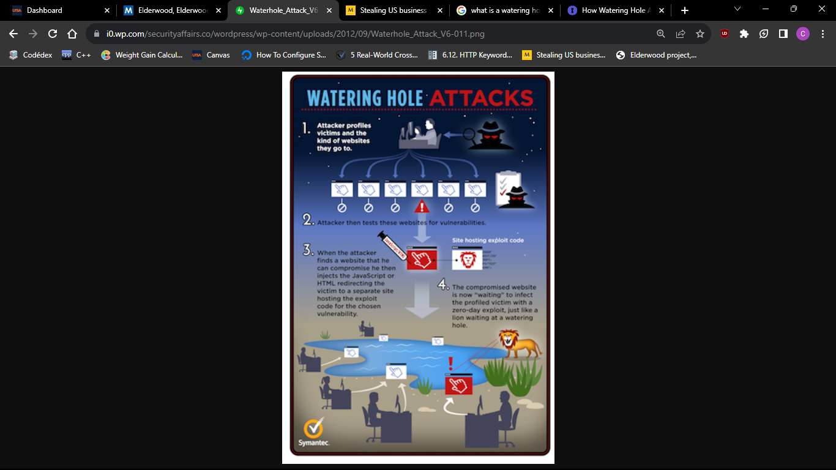

#### Screenshot 2

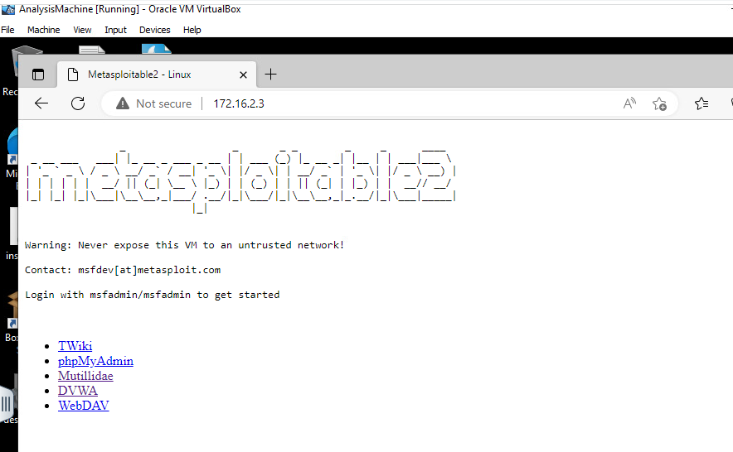



#### Screenshot 3

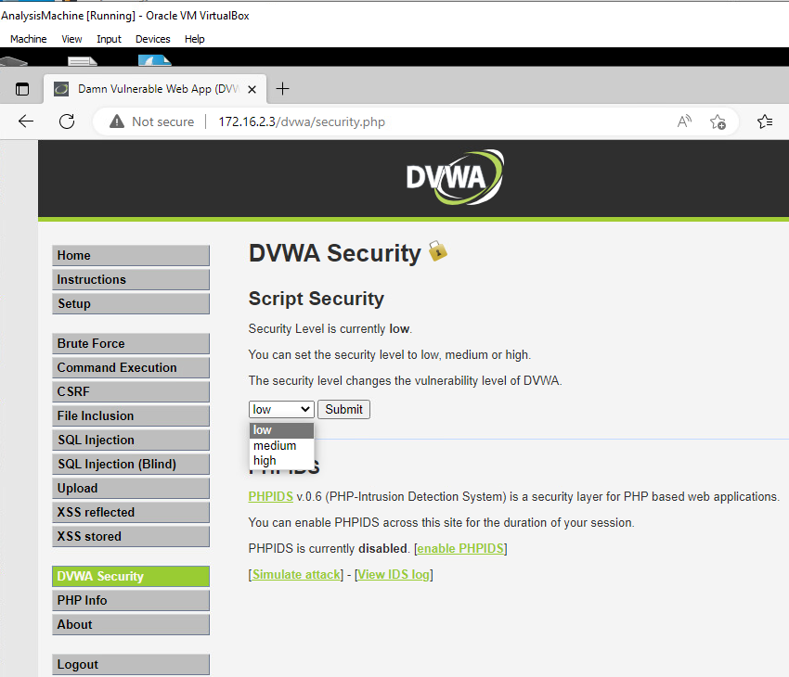



#### Screenshot 4

#### 



#### Screenshot 5

#### 



#### Screenshot 6

#### 



#### Screenshot 7

#### 



#### Screenshot 8

#### 



#### Screenshot 9

#### 



#### Screenshot 10

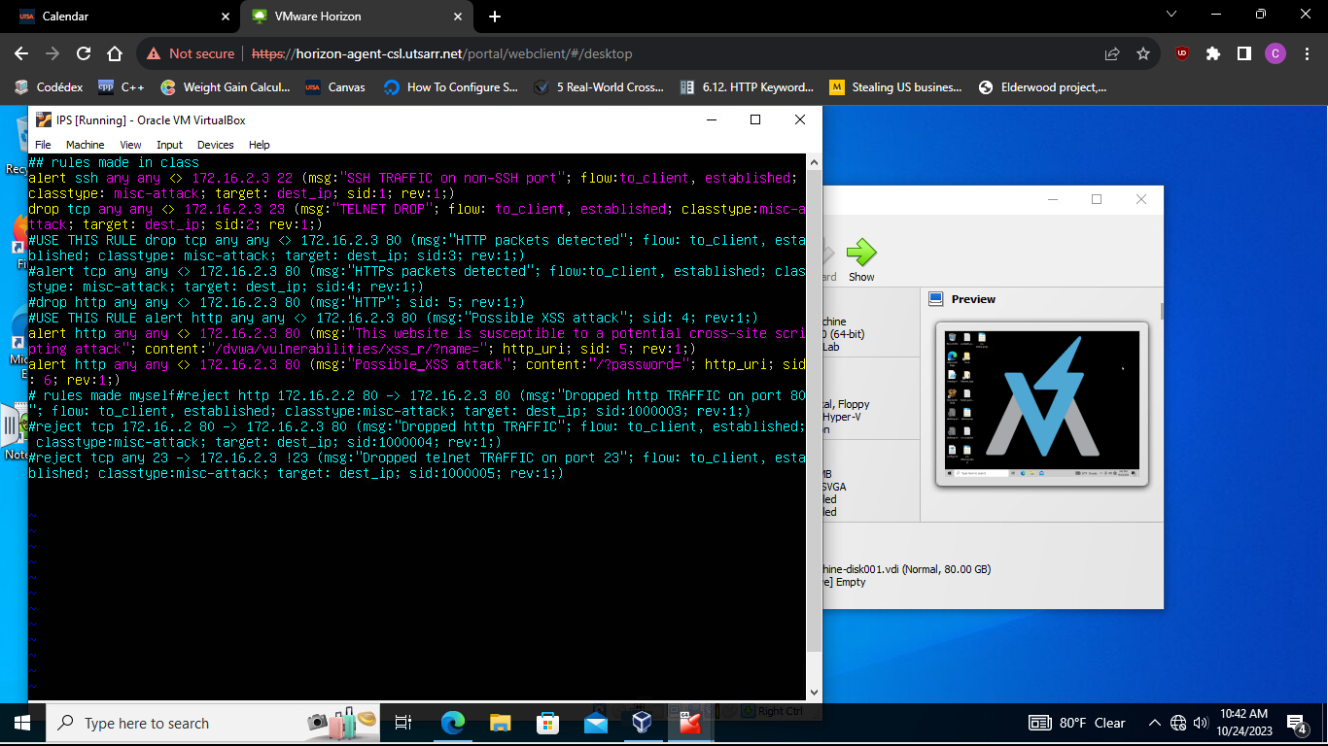



#### Screenshot 11

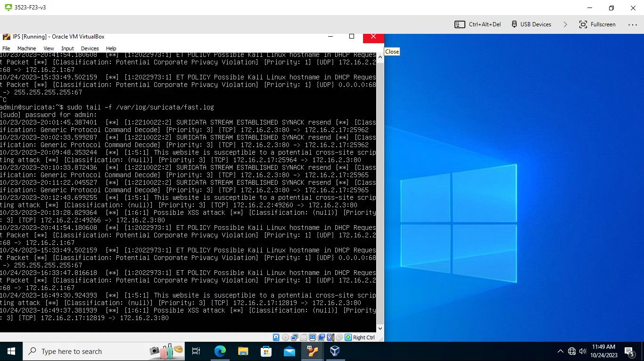



#### Screenshot 12

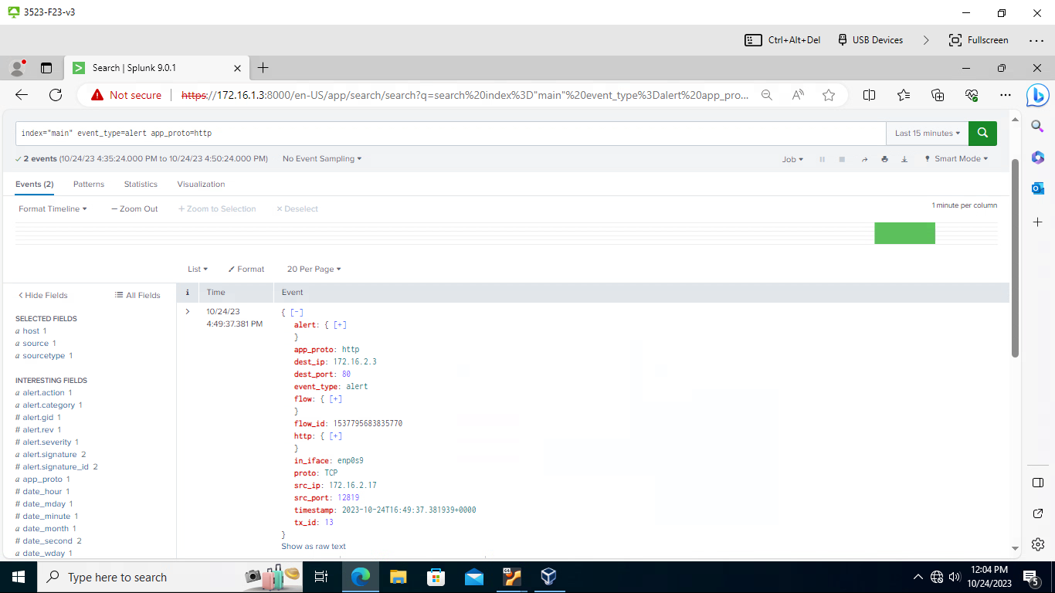



#### Screenshot 13

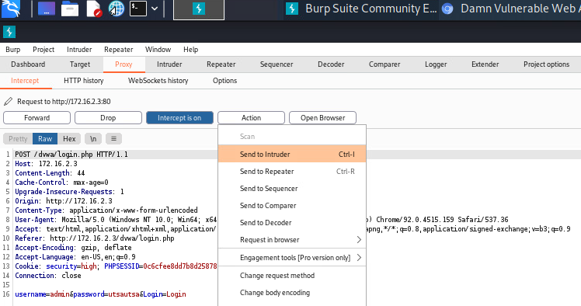



#### Screenshot 14

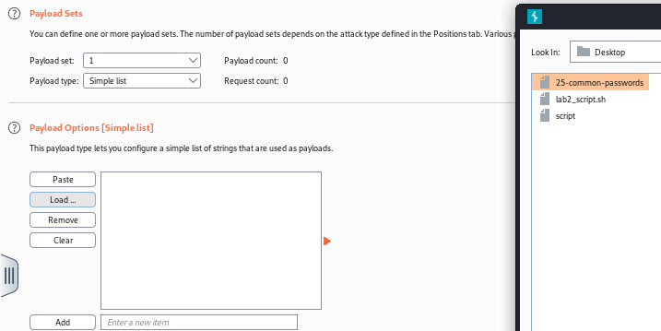



#### Screenshot 15

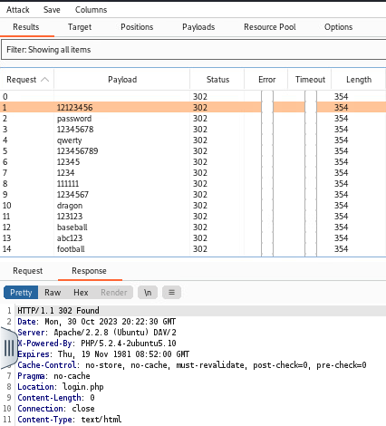



#### Screenshot 16

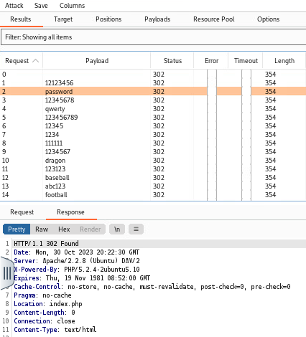



#### Screenshot 17

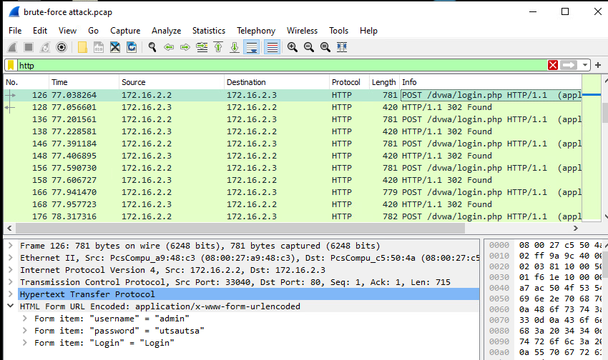



#### Screenshot 18

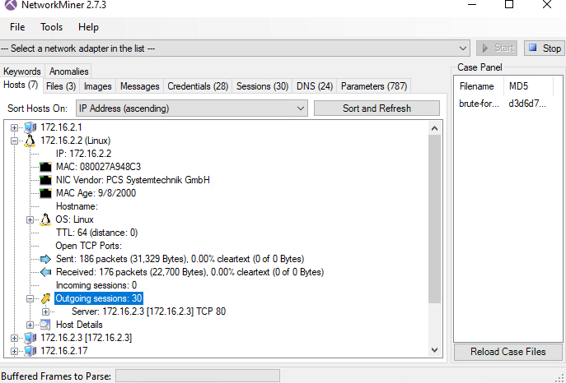



#### Screenshot 19

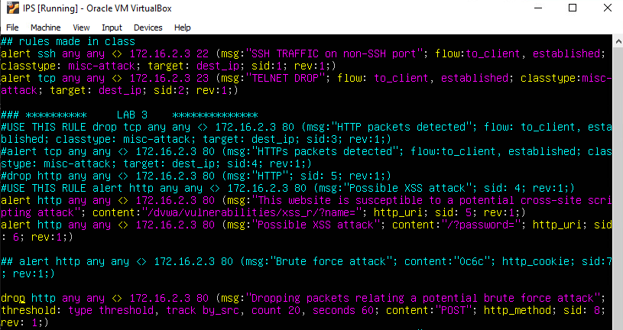

#### Screenshot 20

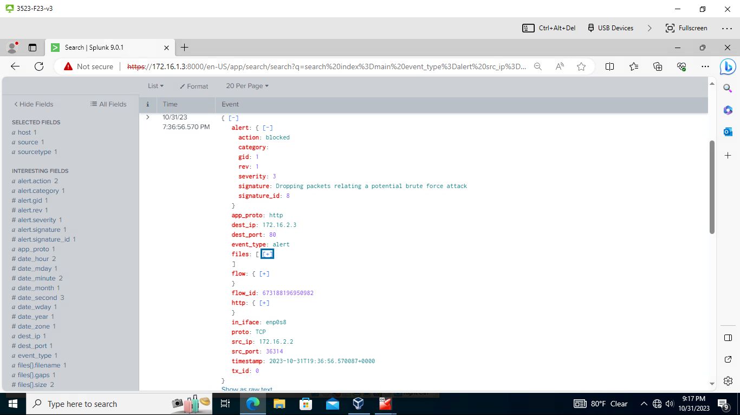



#### Screenshot 21

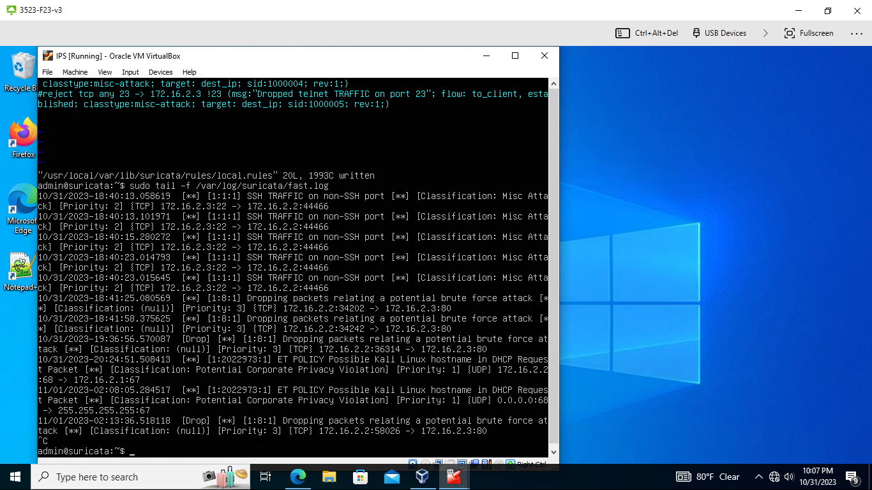



#### Screenshot 22

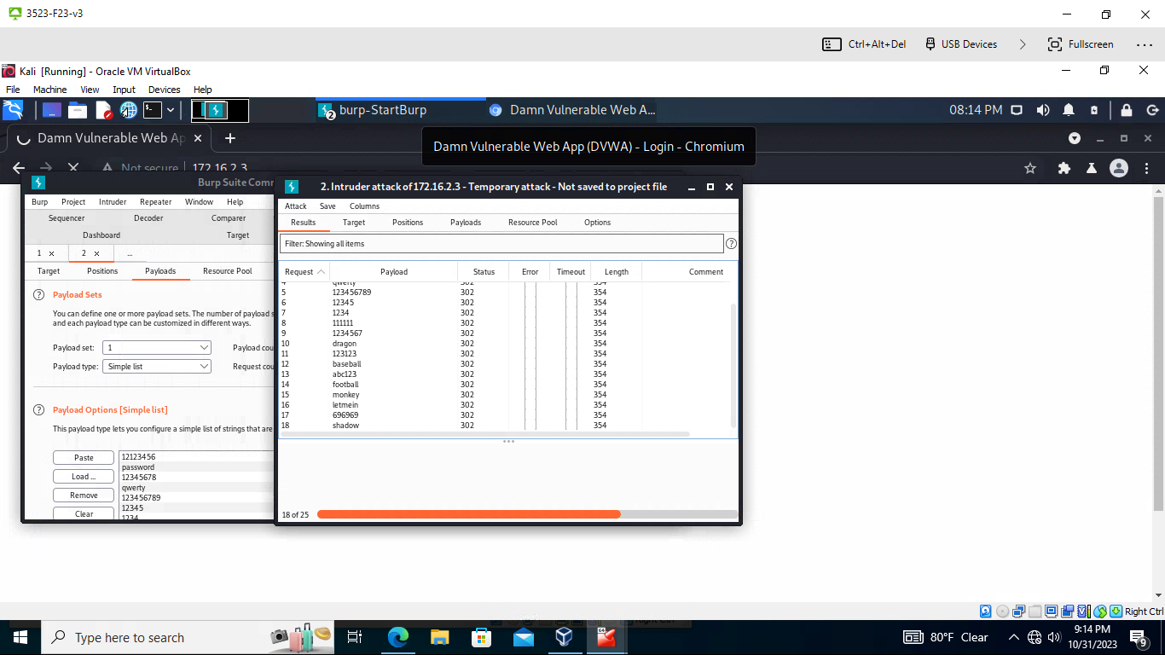



# Works Cited

*6.31. Thresholding keywords*. 6.31. Thresholding Keywords - Suricata 6.0.0 documentation. (n.d.). https://docs.suricata.io/en/suricata-6.0.0/rules/thresholding.html

*Brute Force*. Brute Force, Technique T1110 - Enterprise | MITRE ATT&CK®. (n.d.). https://attack.mitre.org/techniques/T1110/

*Cyber Threat Group Lyceum Takes Center Stage in middle east campaign*. Secureworks. (n.d.). https://www.secureworks.com/blog/lyceum-takes-center-stage-in-middle-east-campaign

*Drive-by compromise*. Drive-by Compromise, Technique T1189 - Enterprise | MITRE ATT&CK®. (n.d.). https://attack.mitre.org/techniques/T1189/

*HTTP keywords*. 6.12. HTTP Keywords - Suricata 6.0.0 documentation. (n.d.). https://docs.suricata.io/en/suricata-6.0.0/rules/http-keywords.html#rules-http-uri-normalization

Paganini, P. (2017, August 27). *Elderwood project, who is behind op. Aurora and ongoing attacks?*. Security Affairs. https://securityaffairs.co/8528/hacking/elderwood-project-who-is-behind-op-aurora-and-ongoing-attacks.html

*Quick start guide*. Quick Start Guide | Metasploit Documentation. (n.d.). https://docs.rapid7.com/metasploit/

Team, C. (2022, August 10). *5 real-World Cross site scripting examples*. Website Security Store. https://websitesecuritystore.com/blog/real-world-cross-site-scripting-examples/

The Christian Science Monitor. (2012, September 14). *Stealing US business secrets: Experts ID two huge Cyber “gangs” in China*. The Christian Science Monitor. https://www.csmonitor.com/USA/2012/0914/Stealing-US-business-secrets-Experts-ID-two-huge-cyber-gangs-in-China

YouTube. (2021, August 6). *How easy is it for hackers to brute force login pages?!*. YouTube. https://www.youtube.com/watch?v=Gz59MezA3r4